**DATA-225 Sec 11 - Db Systems for Analytics**

**PROJECT CODE**

**SQL QUERIES:**

Create database EV;

show databases;

use EV;

CREATE TABLE zev_sales (

county VARCHAR(50),

zev_sale_share_Q1_2022 FLOAT,

zev_sale_share_Q1_Q2_2022 FLOAT,

zev_sale_share_Q1_Q3_2022 FLOAT,

zev_sale_share_Q1_Q4_2022 FLOAT

);

CREATE TABLE vehicle_population (

year INTEGER,

county TEXT,

fuel_type TEXT,

make TEXT,

model TEXT,

unit_sold INTEGER

);

CREATE TABLE vehicle_sales (

year INT,

county VARCHAR(255),

fuel_type VARCHAR(255),

make VARCHAR(255),

model VARCHAR(255),

unit_sold INT

);

CREATE TABLE charging_stations (

county VARCHAR(50),

public_level_1 INT,

shared_private_level_1 INT,

public_level_2 INT,

shared_private_level_2 INT,

public_dc_fast INT,

shared_private_dc_fast INT,

total INT,

year INT,

quarter VARCHAR(2)

);

select * from vehicle_population LIMIT 5;

select * from charging_stations LIMIT 5;

select * from zev_sales LIMIT 5;

select * from vehicle_sales LIMIT 5;

-- SQL query to total number of vehicle sales that have an electric as fuel type

select COUNT(*) from vehicle_sales WHERE FUEL_TYPE = 'ELECTRIC';

-- SQL query to get the top 15 sales, their corresponding counties, and the quarter in which the sales occurred

- The query is selecting the county, the highest ZEV sale share among Q1, Q2, Q3, and Q4 for each county, and the corresponding quarter when the highest sale share occurred. It uses a **CASE** statement to determine the highest sales share and the corresponding quarter for each county.

The **ORDER BY** clause orders the results by the highest ZEV sale share in descending order, and the **LIMIT** clause limits the output to the top 15 results.

The **EXPLAIN** command is used to provide information on how the query will be executed. It shows the execution plan of the query, including the steps taken by the database engine to retrieve the required data. The output of **EXPLAIN** can help identify any performance issues in the query and optimize it accordingly.

SELECT county,

CASE

WHEN zev_sale_share_Q1_2022 >= zev_sale_share_Q1_Q2_2022 AND zev_sale_share_Q1_2022 >= zev_sale_share_Q1_Q3_2022 AND zev_sale_share_Q1_2022 >= zev_sale_share_Q1_Q4_2022 THEN zev_sale_share_Q1_2022

WHEN zev_sale_share_Q1_Q2_2022 >= zev_sale_share_Q1_2022 AND zev_sale_share_Q1_Q2_2022 >= zev_sale_share_Q1_Q3_2022 AND zev_sale_share_Q1_Q2_2022 >= zev_sale_share_Q1_Q4_2022 THEN zev_sale_share_Q1_Q2_2022

WHEN zev_sale_share_Q1_Q3_2022 >= zev_sale_share_Q1_2022 AND zev_sale_share_Q1_Q3_2022 >= zev_sale_share_Q1_Q2_2022 AND zev_sale_share_Q1_Q3_2022 >= zev_sale_share_Q1_Q4_2022 THEN zev_sale_share_Q1_Q3_2022

ELSE zev_sale_share_Q1_Q4_2022

END AS top_sales,

CASE

WHEN zev_sale_share_Q1_2022 >= zev_sale_share_Q1_Q2_2022 AND zev_sale_share_Q1_2022 >= zev_sale_share_Q1_Q3_2022 AND zev_sale_share_Q1_2022 >= zev_sale_share_Q1_Q4_2022 THEN 'zev_sale_share_Q1_2022'

WHEN zev_sale_share_Q1_Q2_2022 >= zev_sale_share_Q1_2022 AND zev_sale_share_Q1_Q2_2022 >= zev_sale_share_Q1_Q3_2022 AND zev_sale_share_Q1_Q2_2022 >= zev_sale_share_Q1_Q4_2022 THEN 'zev_sale_share_Q1_Q2_2022'

WHEN zev_sale_share_Q1_Q3_2022 >= zev_sale_share_Q1_2022 AND zev_sale_share_Q1_Q3_2022 >= zev_sale_share_Q1_Q2_2022 AND zev_sale_share_Q1_Q3_2022 >= zev_sale_share_Q1_Q4_2022 THEN 'zev_sale_share_Q1_Q3_2022'

ELSE 'zev_sale_share_Q1_Q4_2022'

END AS top_quarter

FROM zev_sales

ORDER BY top_sales DESC

LIMIT 15;

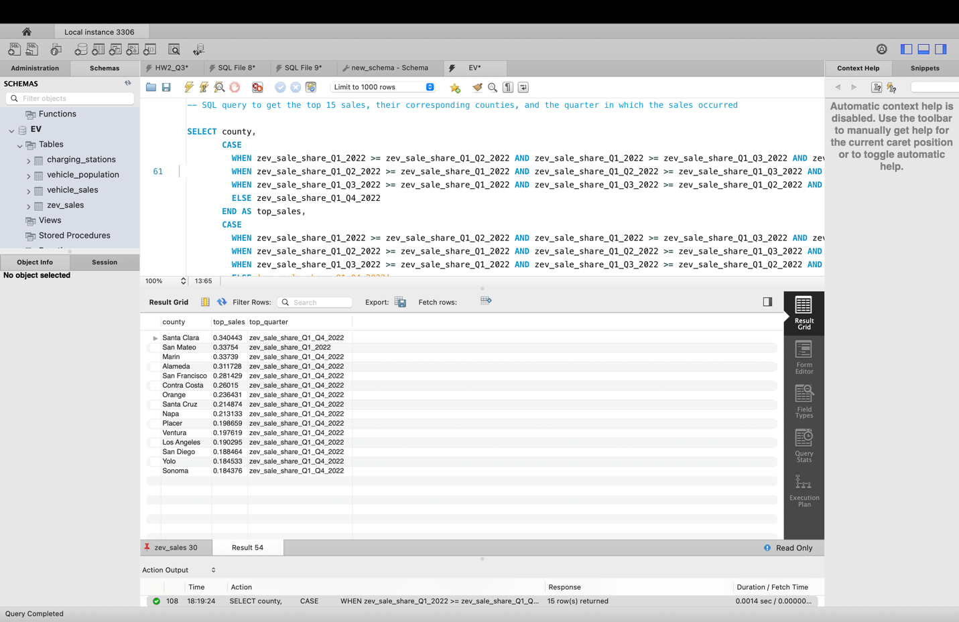

-- Get the total number of EV chargers installed in each county by level

- -   
This SQL query selects the county and the total number of electric vehicle chargers by charger type (public level 1, shared private level 1, public level 2, shared private level 2, public DC fast, shared private DC fast, total) for each county. It then groups the results by county using the GROUP BY clause.

The SUM function is used to aggregate the number of chargers for each charger type and the total number of chargers. The result set is sorted by county.

In summary, this query retrieves the total number of electric vehicle chargers by charger type and county, allowing for analysis of the availability and distribution of charging infrastructure.

SELECT county,

SUM(public_level_1) AS total_public_level_1,

SUM(shared_private_level_1) AS total_shared_private_level_1,

SUM(public_level_2) AS total_public_level_2,

SUM(shared_private_level_2) AS total_shared_private_level_2,

SUM(public_dc_fast) AS total_public_dc_fast,

SUM(shared_private_dc_fast) AS total_shared_private_dc_fast,

SUM(total) AS total_ev_chargers

FROM charging_stations

GROUP BY county;

-- Get the top 10 best-selling vehicle models in a specific county and year

SELECT make, model, SUM(unit_sold) AS total_sales

FROM vehicle_population

GROUP BY make, model

ORDER BY total_sales DESC

LIMIT 10;

-- Calculate the percentage of ZEV sales in each county for each quarter in 2022

SELECT Z.county,

zev_sale_share_Q1_2022,

zev_sale_share_Q1_Q2_2022,

zev_sale_share_Q1_Q3_2022,

zev_sale_share_Q1_Q4_2022

FROM zev_sales as Z, vehicle_sales as V

WHERE V.year = 2022;

-- Get the total number of Electric's sold in each county in 2022

SELECT county, SUM(unit_sold) AS total_zev_sales

FROM vehicle_sales

WHERE fuel_type = 'Electric' AND year = 2022

GROUP BY county;

-- Get the total number of EV chargers installed in California by year

SELECT year, quarter, SUM(total) AS total_ev_chargers

FROM charging_stations

WHERE county = 'California'

GROUP BY year;

-- Get the top 5 counties with the highest percentage of ZEV sales in Q1 2022

SELECT county, zev_sale_share_Q1_2022

FROM zev_sales

WHERE zev_sale_share_Q1_2022 IS NOT NULL

ORDER BY zev_sale_share_Q1_2022 DESC

LIMIT 5;

-- Get the total number of ZEV sales by make in Contra Costa in 2022

SELECT year, SUM(public_level_2) AS total_public_level_2

FROM charging_stations

WHERE county = 'Contra Costa'

GROUP BY year;

-- Get the total number of ZEV sales by make in California in 2022:

SELECT make, SUM(unit_sold) AS total_zev_sales

FROM zev_sales

WHERE county = 'California' AND year = 2022

GROUP BY make

ORDER BY total_zev_sales DESC;

-- Get the total number of EV chargers installed in each county for each quarter in 2022

SELECT county, quarter, SUM(total) AS total_ev_chargers

FROM charging_stations

WHERE year = 2022

GROUP BY county, quarter;

**ELASTIC SEARCH:**

**DASHBOARD**

**SEARCH USING FILTERS:**

**Snowflake:**



